Project Planning Phase
Project Planning Template (Product Backlog, Sprint Planning, Stories, Story points)

Date | 30-09-2026
Team ID | SWTID-2026-5703
Project Name | AI-Augmented Backend Development AI FitTrack API
Maximum Marks | 5 Marks

Product Backlog, Sprint Schedule, and Estimation (4 Marks)
Use the below template to create product backlog and sprint schedule
Sprint | Functional Requirement (Epic) | User Story Number | User Story / Task | Story Points | Priority | Team Members
Sprint-1 | Registration | USN-1 | As a user, I can register with my name, email and password so that my workout data is stored under my own account. | 5 | High | Sivanesh S
Sprint-1 | Login | USN-2 | As a user, I can log in with my email and password and receive a JWT token to access protected APIs. | 5 | High | Selvaganapathi M
Sprint-1 | Profile | USN-3 | As an authenticated user, I can view my profile (id, name, email). | 3 | Medium | Suriya K
Sprint-1 | Project Setup & Database | USN-13 | As a developer, I can set up the Node.js/Express MVC project and connect MongoDB through Mongoose with User and Workout schemas. | 5 | High | Subash I
Sprint-1 | Security | USN-14 | As a developer, I can hash passwords with bcrypt.js and protect routes with JWT authentication middleware. | 2 | High | Suriya K
Sprint-2 | Workout Management | USN-4 | As a user, I can add a workout (name, category, duration, calories burned, date). | 4 | High | Subash I
Sprint-2 | Workout Management | USN-5 | As a user, I can view all my workouts. | 3 | High | Sivanesh S
Sprint-2 | Workout Management | USN-6 | As a user, I can retrieve a single workout by its ID. | 3 | Medium | Sivanesh S
Sprint-2 | Workout Management | USN-7 | As a user, I can update a workout record. | 3 | Medium | Selvaganapathi M
Sprint-2 | Workout Management | USN-8 | As a user, I can delete a workout record. | 3 | Medium | Selvaganapathi M
Sprint-2 | Workout Search | USN-9 | As a user, I can search my workouts by name, category or date. | 4 | Medium | Suriya K
Sprint-3 | AI Integration | USN-15 | As a developer, I can build a Gemini service layer that prepares prompts and formats AI responses. | 5 | High | Suriya K
Sprint-3 | AI Recommendation | USN-10 | As a user, I can submit my age, fitness goal and experience level to get a personalised workout recommendation. | 5 | High | Subash I
Sprint-3 | AI Insights | USN-11 | As a user, I can submit total workouts, average duration and calories burned to get AI fitness insights. | 5 | High | Sivanesh S
Sprint-3 | AI Reliability | USN-16 | As a developer, I can add retry and automatic fallback to a secondary Gemini model when the primary model is unavailable. | 5 | Medium | Selvaganapathi M
Sprint-4 | Error Handling | USN-12 | As a user, I receive clear JSON error messages for invalid credentials, missing tokens and validation errors. | 5 | High | Selvaganapathi M
Sprint-4 | API Testing | USN-17 | As a tester, I can verify all authentication, workout and AI endpoints using Postman / Thunder Client. | 5 | High | Sivanesh S
Sprint-4 | Documentation | USN-18 | As a team, we document the architecture, setup, schemas and API test results. | 5 | Medium | Subash I
Sprint-4 | Demo & Delivery | USN-19 | As a team, we record the demo and API testing videos and publish the code to GitHub. | 5 | Medium | Suriya K

Project Tracker, Velocity & Burndown Chart: (4 Marks)
Sprint | Total Story Points | Duration | Sprint Start Date | Sprint End Date (Planned) | Story Points Completed (as on Planned End Date) | Sprint Release Date (Actual)
Sprint-1 | 20 | 4 Days | 15 Sep 2026 | 18 Sep 2026 | 20 | 18 Sep 2026
Sprint-2 | 20 | 4 Days | 19 Sep 2026 | 22 Sep 2026 | 20 | 22 Sep 2026
Sprint-3 | 20 | 4 Days | 23 Sep 2026 | 26 Sep 2026 | 20 | 26 Sep 2026
Sprint-4 | 20 | 4 Days | 27 Sep 2026 | 30 Sep 2026 | 20 | 30 Sep 2026

Velocity:
For AI FitTrack, the sprint duration is 4 days and the team velocity is 20 story points per sprint. Average velocity (AV) per iteration unit (story points per day) = Velocity / Sprint Duration = 20 / 4 = 5 story points per day.

Burndown Chart:
A burn down chart is a graphical representation of work left to do versus time. It is often used in agile software development methodologies such as Scrum. However, burn down charts can be applied to any project containing measurable progress over time.
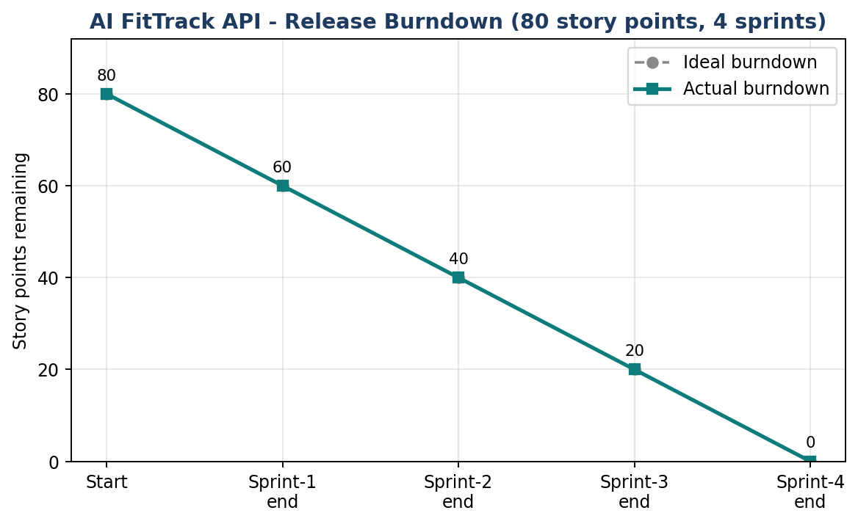

References:
AI FitTrack API - project source code (GitHub): https://github.com/ksuriyamsdgk-max/Ai-Augmented-Backend-Development-AI-FitTrack-API
Express.js - Routing guide: https://expressjs.com/en/guide/routing
Postman - Quick start for sending and testing API requests: https://learning.postman.com/docs/getting-started/quick-start
Sample Node.js/Express REST API with JWT, bcrypt and MongoDB (GitHub): https://github.com/lmnance2/Node-Express-Tutorial
MVC with Node.js, Express and Mongoose (GitHub lab): https://github.com/unminnn/0-mvc_intro

